**Google Scholar - Library Links**

Google Scholar can be used to search for scholarly information online, including articles, books, conference papers, theses, grey literature, and official reports.  Linking your Library and Knowledge Service to Google Scholar will ensure that you get access to any full text that we subscribe to for your organisation.

Go to *Google Scholar*: <https://scholar.google.com/>

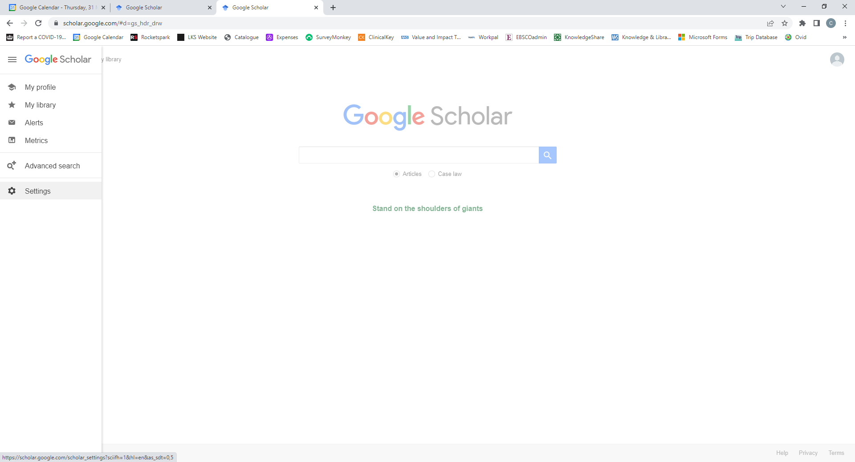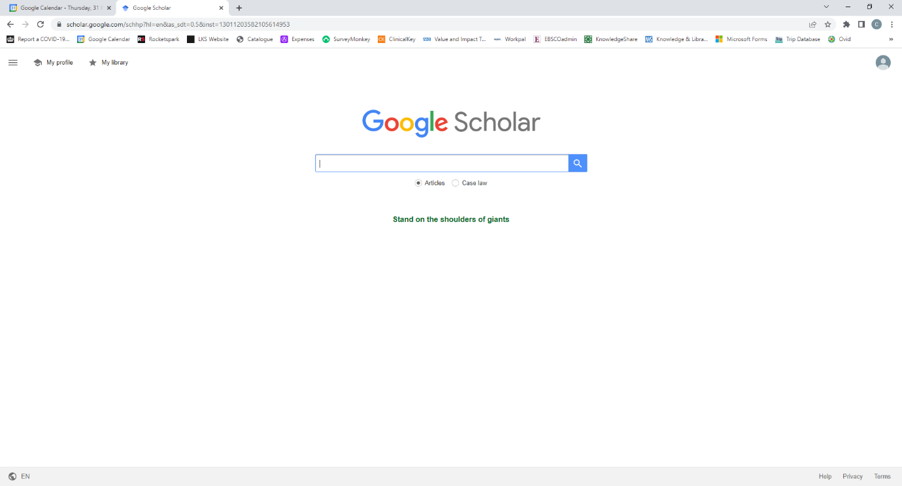

Click on the 3 horizontal lines in the top left hand corner of the screen.

Select **Settings**.

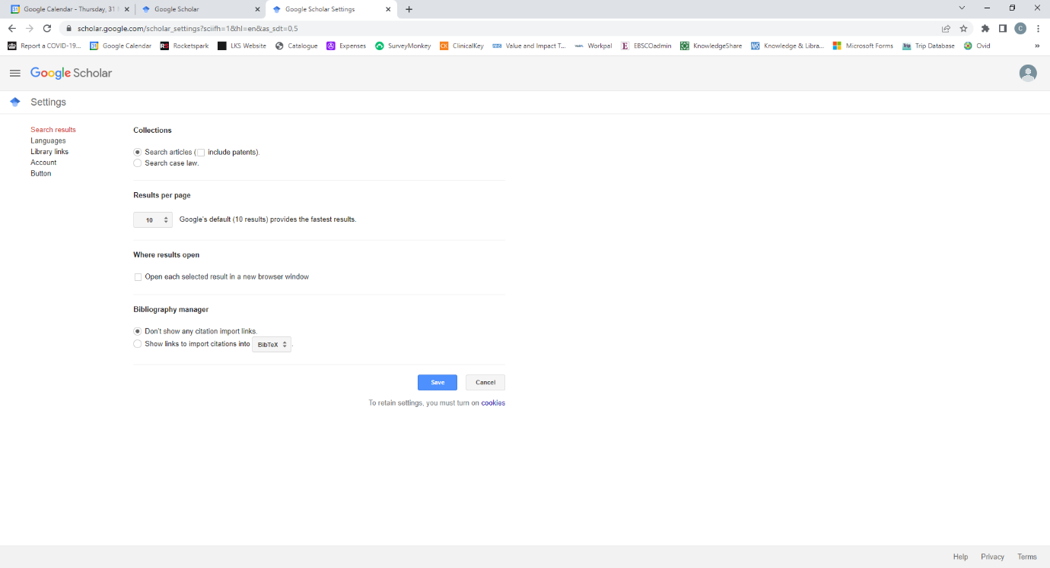

Select **Library links**

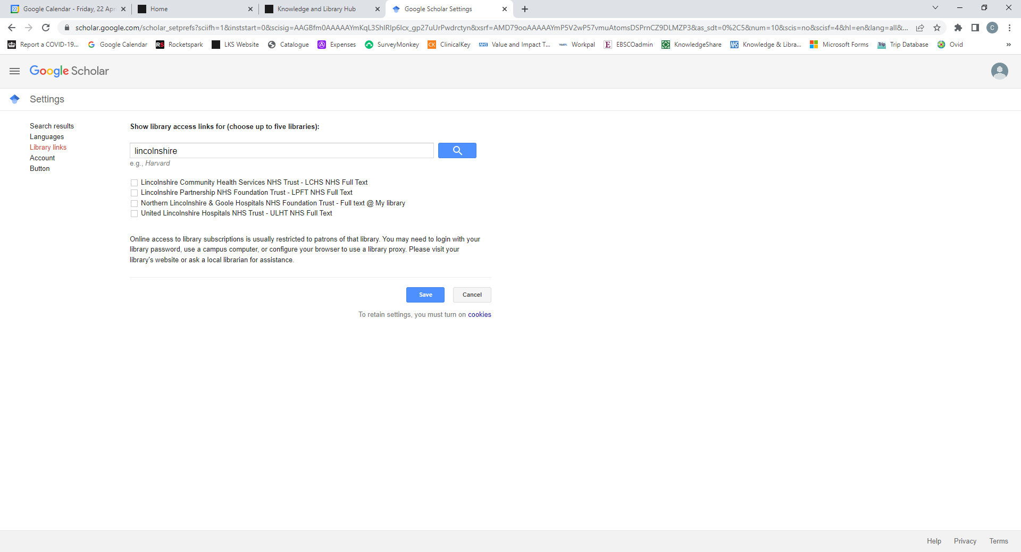

Type **Lincolnshire** into the search box and click on the *Magnifying Glass* button.

The different organisations in Lincolnshire should then be showing.

Select your organisation and then click on **Save**.

You can select up to 5 libraries and you can change these at any time. The links to full text articles will then show in *Google Scholar* (either LCHS NHS Full Text / LPFT NHS Full Text / ULHT NHS Full Text).

